**Pizza Sales Project SQL QUERIES**

1.Select SUM(total_price) As Total_Revenue

From pizza_sales

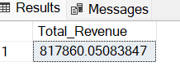

2.select SUM(total_price)/COUNT(DISTINCT order_id) As Average_order_value

From pizza_sales

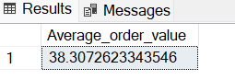

3.Select SUM(QUANTITY)AS Total_Pizza

From pizza_sales

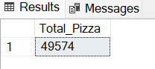

4.Select COUNT(Distinct order_id)As Total_orders

From pizza_sales

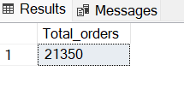

5.SELECT CAST (CAST(SUM(quantity)AS DECIMAL(10,2))/

CAST (COUNT(DISTINCT order_id)AS DECIMAL(10,2)) AS DECIMAL(10,2))AS AVERAGE_PIZZA_PER_ORDER

From pizza_sales

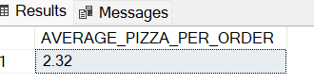

6. SELECT DATENAME(DW, ORDER_date) as order_day, COUNT(DISTINCT ORDER_ID)AS TOTAL_ORDERS

FROM pizza_sales

GROUP BY DATENAME(DW, ORDER_DATE)

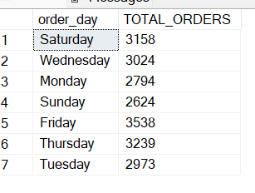

7. SELECT DATENAME(MONTH, ORDER_DATE) AS MONTH_NAME, COUNT(DISTINCT ORDER_ID) as Total_Orders

FROM pizza_sales

group by DATENAME(MONTH, ORDER_DATE)

Order by Total_Orders DESC

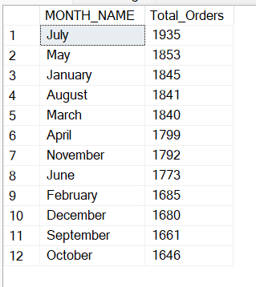

8. select pizza_category, SUM(total_price) *100/ (select sum(total_price) from pizza_sales) As Percentage_of_total

from pizza_sales

Group by pizza_category

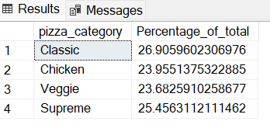

9. select pizza_category, sum(total_price) as Total_Sales, SUM(total_price) *100/

(select sum(total_price) from pizza_sales WHERE MONTH(Order_date)= 1) As Percentage_of_total

from pizza_sales

WHERE MONTH(Order_date)= 1

Group by pizza_category

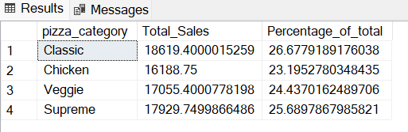

10. select pizza_size, sum(total_price) as Total_Sales, SUM(total_price) *100/

(select sum(total_price) from pizza_sales WHERE MONTH(Order_date)= 1) As Percentage_of_total

from pizza_sales

WHERE MONTH(Order_date)= 1

Group by pizza_size

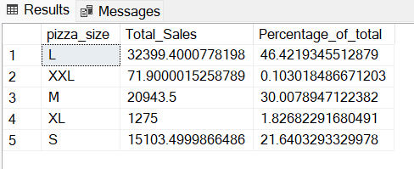

11. select pizza_size, CAST(sum(total_price)AS DECIMAL(10,2)) as Total_Sales,CAST (SUM(total_price) *100/

(select sum(total_price) from pizza_sales)AS DECIMAL(10,2)) As Percentage_of_total

from pizza_sales

WHERE DATEPART(quarter, order_date)=1

Group by pizza_size

Order by Percentage_of_total DESC

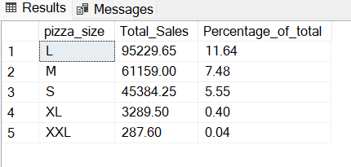

12. SELECT TOP 5 pizza_name, SUM(total_price) AS Total_Revenue from pizza_sales

group by pizza_name

Order by Total_Revenue DESC

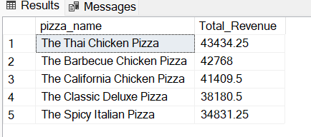

**Bottom 5 Pizzas**

13. SELECT TOP 5 pizza_name, SUM(total_price) AS Total_Revenue from pizza_sales

group by pizza_name

Order by Total_Revenue ASC

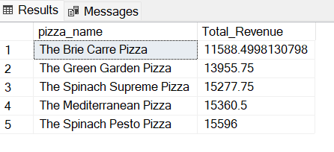

14. SELECT TOP 5 pizza_name, SUM(quantity) AS Total_quantity from pizza_sales

group by pizza_name

Order by Total_quantity DESC

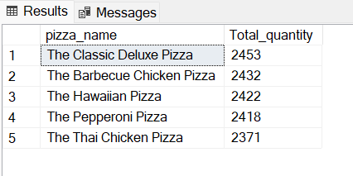

15. SELECT TOP 5 pizza_name, COUNT(DISTINCT order_id) AS Total_Orders from pizza_sales

group by pizza_name

Order by Total_Orders DESC

